# Setting Up MySQL Database Connection in Unreal Engine

## Overview

This documentation provides a step-by-step guide to set up a connection to a MySQL database using Unreal Engine. It covers prerequisites, installation, and configuration steps necessary to integrate MySQL with Unreal Engine projects.

## Prerequisites

Before proceeding with the setup, ensure the following prerequisites are met:

* Unreal Engine version 4.26 or later.
* Visual Studio with C++ Unreal Engine extension installed.
* Windows 10 or later with SDK files installed.

## Pre-download:

1. **Setup Visual Studio and Unreal Engine**

* Install Visual Studio with the game development with c++ and enable Unreal Engine in right panel.
* Ensure Windows 10 and necessary SDK files are installed.

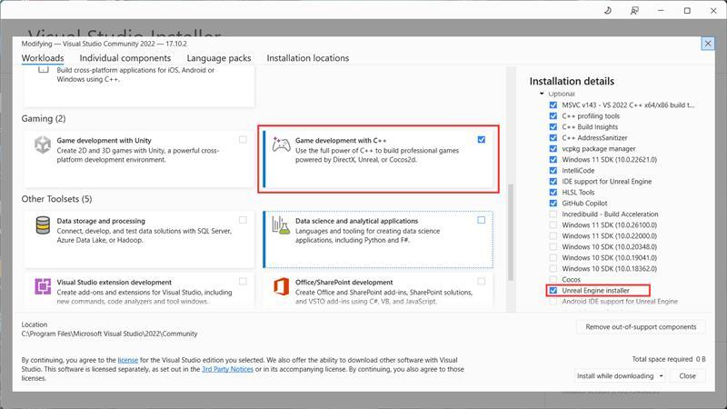

1. **Prepare Cloud Database**

Obtain credentials for an active cloud database:

* Host
* Username
* Password
* Database name

Create a table in the database.

1. **Add Initial Data**

Insert a row into the database table, e.g., hello.

## Download and Installation

1. **Download MySQL Plugin for Unreal Engine**

Download the plugin file, e.g., MysqlDBUnrealengine4.26, and extract it to a separate folder.

[GitHub - darkgoogle/MysqlDBUnrealengine4.26](https://github.com/darkgoogle/MysqlDBUnrealengine4.26)

1. **Integrate Plugin with Unreal Engine Project**

* Navigate to your Unreal Engine project directory.
* Create a new folder named Plugins if it doesn't exist.
* Copy the extracted plugin folder into <project_directory>/Plugins/.
* Create a new c++ class by tools->new c++ class->none... Before generating visual studio project files

1. **Generate Visual Studio Files**

Right-click on your project file and select "Generate Visual Studio Files".

**Build the Project**

* Open Visual Studio.
* Ensure all required Unreal Engine options are selected during installation.
* If the project file is not visible in Solution Explorer, go to File > Open > Select the project folder.

**Build the Project**

* Right-click on the project file in Visual Studio and select "Build".
* Resolve any build issues that may arise (e.g., configuration.xml file conflicts).

## Post-installation Configuration

**Configure Plugin in Unreal Engine**

* Open your Unreal Engine project.
* Navigate to Edit > Plugins.
* Search for MySQL plugin and ensure it is enabled.
* Open level blueprint and add Begin Play node.
* Connect Begin Play with mysqlconnect plugin node.
* Enter cloud database connection details.

**Test Connection**

Verify the connection by adding nodes to:

* On Success: Print "Hello".
* On Error: Print error message.

**Execute MySQL Query**

* Use mysql execute query node to test database interaction.
* Enter the query, e.g., SELECT * FROM table_name WHERE row_name='hello'.

**Verification**

* Run the project.
* Check the black simulation screen for successful database setup.

## Conclusion

By following these steps, you should have successfully set up a MySQL database connection in your Unreal Engine project. For further assistance or troubleshooting, refer to Unreal Engine and MySQL documentation resources.

[Download Visual Studio Tools - Install Free for Windows, Mac, Linux (microsoft.com)](https://visualstudio.microsoft.com/downloads/)

[GitHub - darkgoogle/MysqlDBUnrealengine4.26](https://github.com/darkgoogle/MysqlDBUnrealengine4.26)

Author : DEV SONI